**PostgreSQL Create User + ReadOnly**

1. Buka PgAdmin, expand database > masuk ke database yang dipilih > klik kanan > pilih Query Tool untuk melakukan query

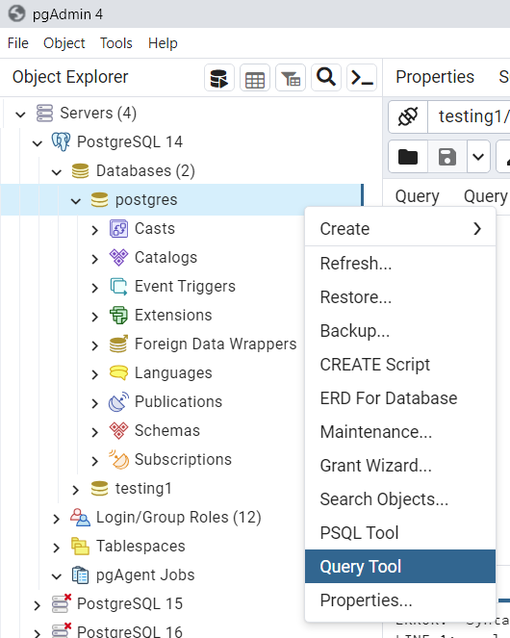

1. Create a Role “readaccess” pada query tool di PgAdmin

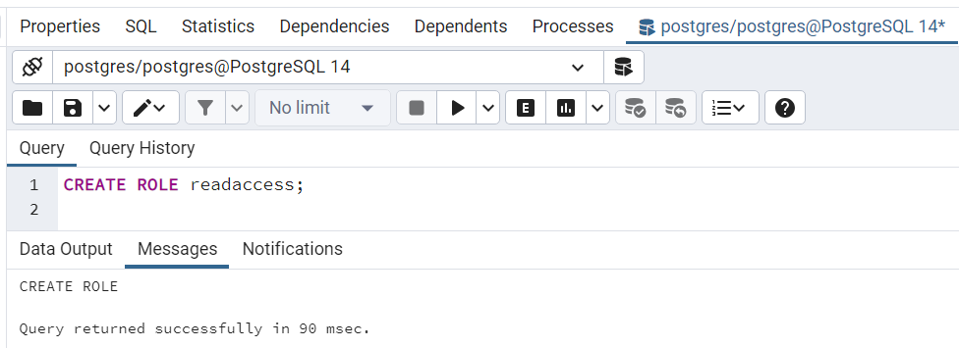

1. Assign Multiple Permissions. Ketika role readaccess telah dibuat, berikan akses Grant ke beberapa permissions.
2. Permission **connect DB**

GRANT CONNECT ON DATABASE [nama database]

TO [nama role];

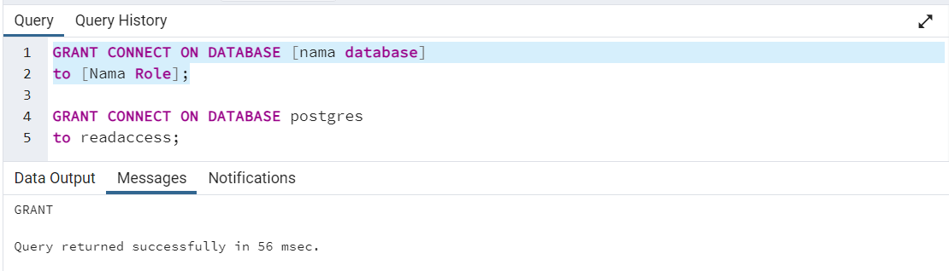

1. Permission **usage on schema**, untuk allow the role to use the public schema of the Postgres database

GRANT USAGE ON SCHEMA public TO [Nama Role];

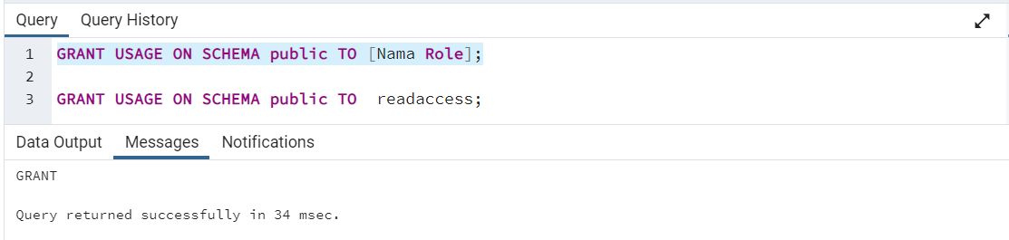

1. Permission **access**, untuk access the tables in the database

GRANT SELECT ON ALL TABLES IN SCHEMA public TO [Nama Role];

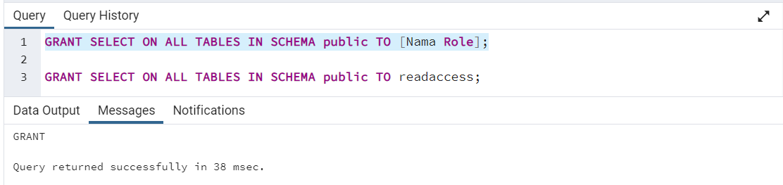

1. Create Read-Only User. Setelah seluruh permission udah diassign ke Role ReadAccess, kemudian execute command untuk membuat user dan password di DB

CREATE USER [Nama User] WITH

PASSWORD '[masukkan password]';

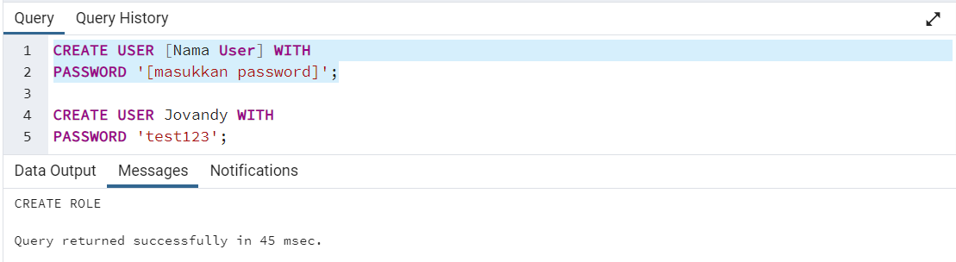

1. Berikan akses user ke role ReadAccess yang dibuat

GRANT [Nama Role] TO [Nama User];

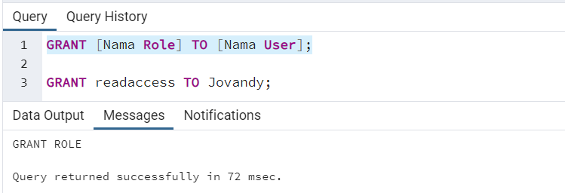

1. Cek di Login/Group Roles

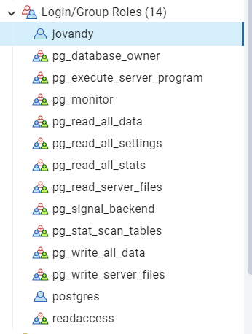

**How to Solve if remote server with pgadmin, pop-up error mesagges SSL Off**

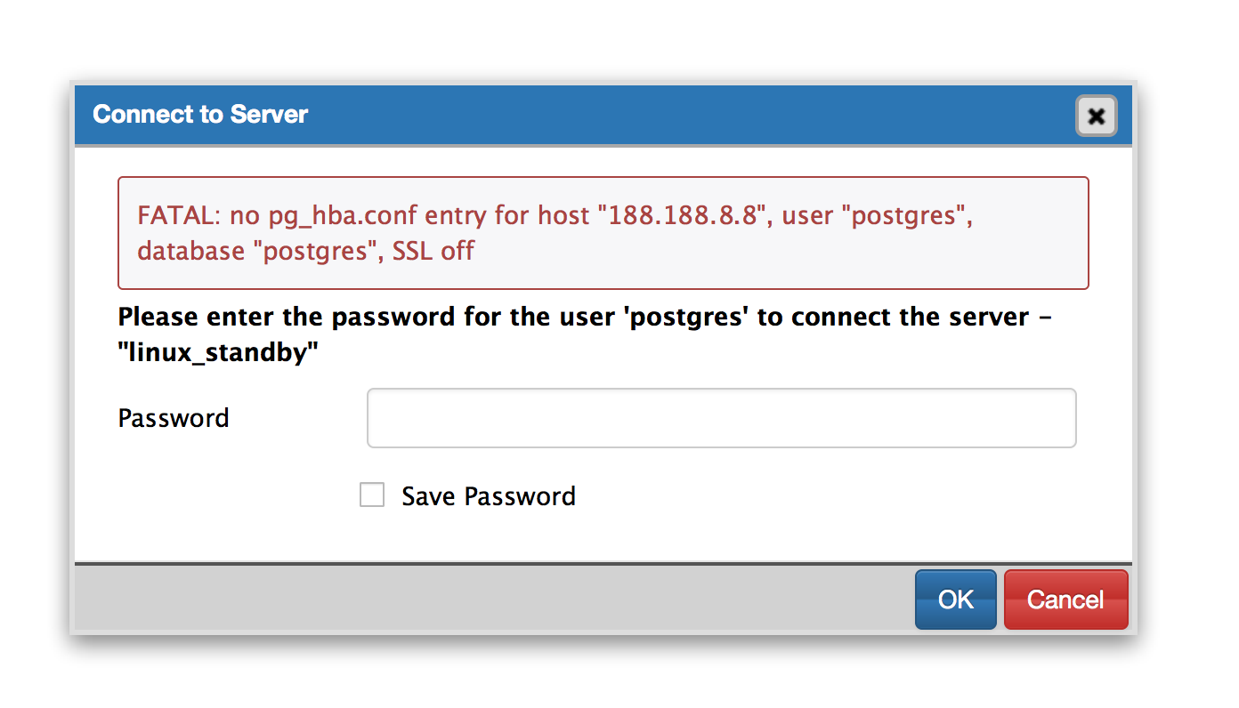

**Cause**

Client authentication is controlled by a configuration file, which traditionally is named pg_hba.conf and is stored in the database cluster's data directory. For more information on postgres configuration file details:

http://www.postgresql.org/docs/9.2/static/auth-pg-hba-conf.html

1. Pastikan server destination sudah open port SSH (22) dan Postgres (5432)
2. Masuk ke server destination with Mobaexterm menggunakan user ‘root’

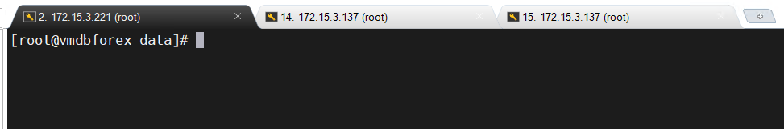

1. If you want to disable SSL instead, be sure to not lose the client connection after you set ssl=off and make changes to the pg_hba. conf file
2. Tambahkan IP Address server source yang akan melakukan remote ke server destination pada file *pg_hba.conf* . Dengan sebelum itu, cari lokasi file *pg_hba.conf* dengan command

locate pg_hba.conf

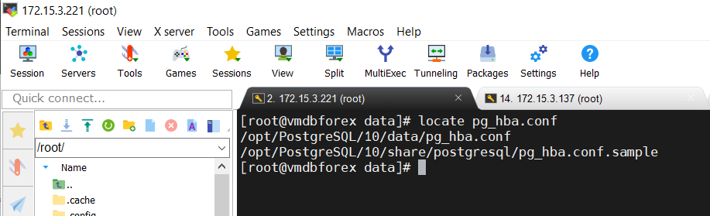

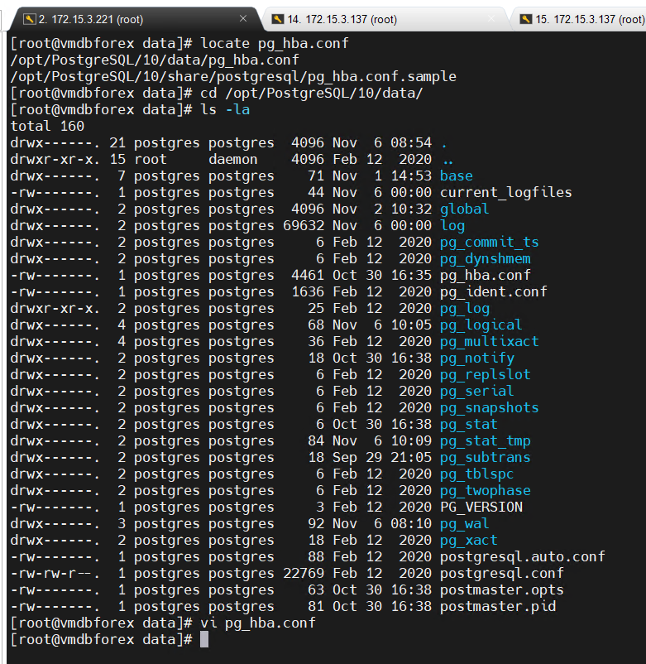

1. Masuk ke file *pg_hba.conf* : vi *pg_hba.conf*

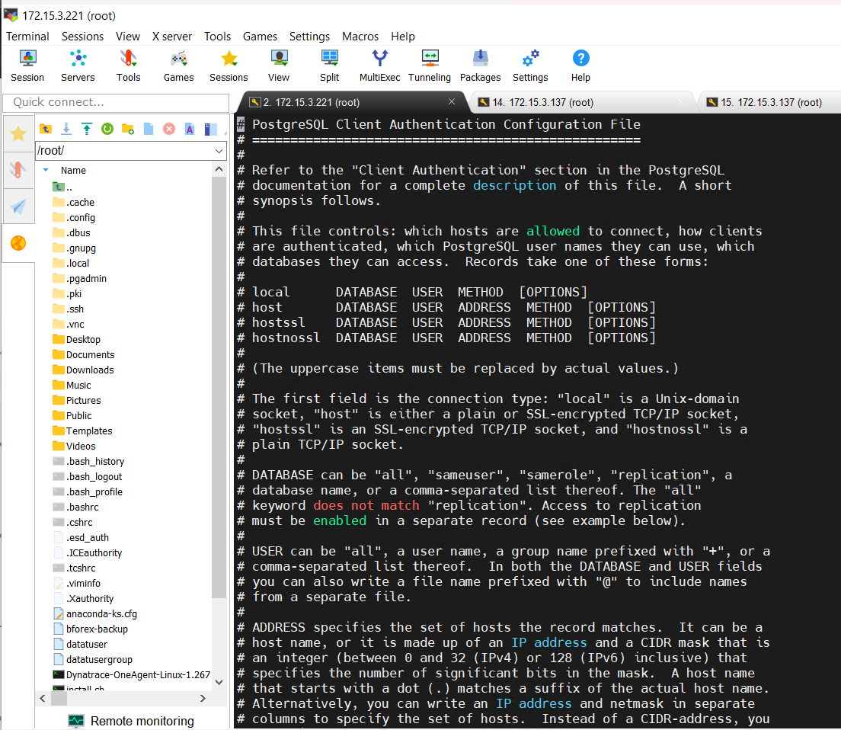

**Resolution**

1. Add the IP address of the application (e.g., Jira) server to the pg_hba.conf and make sure that the method is not set to reject. You need to modify the xxx.xxx.xxx.xxx and put the IP address to allow connections.

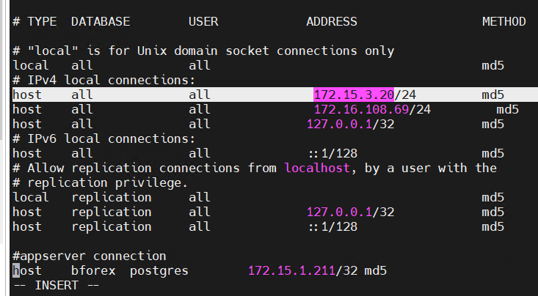

Another example, 192.168.132.17/24 where 24 is the mask which would be 255.255.255.0. If it was 255.255.0.0 then the number would be 16. For more information consult the pg_hba.conf documentation page.

1. After pg_hba.conf has been updated, run the following command in the database to reload the new information added.

SELECT pg_reload_conf()

1. Restart service PostgreSQL

systemctl restart postgresql-10